

Purbanchal University
Faculty of Science & Technology

A LAB REPORT ON

MACHINE LEARNING

Submitted to
Department of Computer Application
Gomendra Multiple College

In partial fulfillment of the requirements for the Masters of Computer Application

Submitted by
Achyut Chapagain (Roll No: 01)
Regd No: 004-3-3-01635-2025

Under the Supervision of
Mr. Madan Tiwari

Table of Contents

1. Basic list, tuple, and dictionary operations. 1
2. Create a 5*5 matrix using NumPy and compute transpose 3
3. Data exploration and preprocessing 5
4. Load a CSV dataset and display summary statistics 7
5. Handle missing values using mean/median 9
6. Simple linear regression for house price prediction 11
7. Plot regression line and interpret slope/intercept 13
8. Naive Bayes classifier for spam detection 15
9. Evaluate Naive Bayes using confusion matrix and classification report 17
10. Logistic regression for student pass prediction 19
11. Visualize logistic regression decision boundary 21
12. Decision tree classifier for Iris dataset 23
13. Visualize decision tree structure 25
14. SVM with linear kernel on Iris dataset 27
15. K-NN classifier for handwritten digits 29
16. Experiment with different K values in K-NN 31
17. WEKA K-means clustering on a dataset 33
18. Compare WEKA and Python sklearn classification results 35

1. Basic list, tuple, and dictionary operations.
Title | Basic list, tuple, and dictionary operations.
Objective | To demonstrate basic operations on list, tuple, and dictionary using Python.
Required Tools/Software | Python 3.x, VS Code/Jupyter Notebook

Problem Statement
To demonstrate basic operations on list, tuple, and dictionary using Python.

Procedure
- Import the required Python libraries.
- Prepare or load the required dataset.
- Apply the machine learning/data processing technique.
- Display the result and evaluate the output.
- Write observation and conclusion.

Program
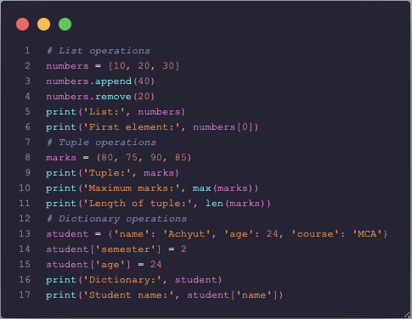

Expected Output
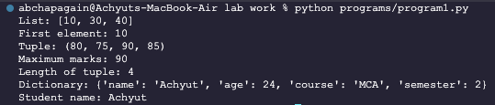

Observation
The program runs successfully and produces the expected result for the given input data.

Conclusion
Lists, tuples, and dictionaries are important Python data structures used to store and process data in AI and ML programs.

2. Create a 5*5 matrix using NumPy and compute transpose
Title | Create a 5x5 matrix using NumPy and compute transpose
Objective | To create a 5x5 matrix and find its transpose using NumPy.
Required Tools/Software | Python 3.x, NumPy

Problem Statement
To create a 5x5 matrix and find its transpose using NumPy.

Procedure
- Import the required Python libraries.
- Prepare or load the required dataset.
- Apply the machine learning/data processing technique.
- Display the result and evaluate the output.
- Write observation and conclusion.

Program
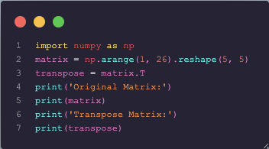

Expected Output
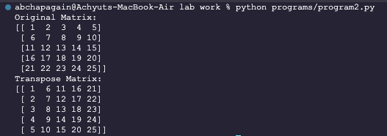
Observation
The program runs successfully and produces the expected result for the given input data.

Conclusion
NumPy makes matrix operations simple and efficient for scientific and machine learning tasks.

3. Data exploration and preprocessing
Title | Data exploration and preprocessing
Objective | To perform basic data exploration and preprocessing on a sample dataset.
Required Tools/Software | Python 3.x, Pandas, NumPy

Problem Statement
To perform basic data exploration and preprocessing on a sample dataset.

Procedure
- Import the required Python libraries.
- Prepare or load the required dataset.
- Apply the machine learning/data processing technique.
- Display the result and evaluate the output.
- Write observation and conclusion.

Program
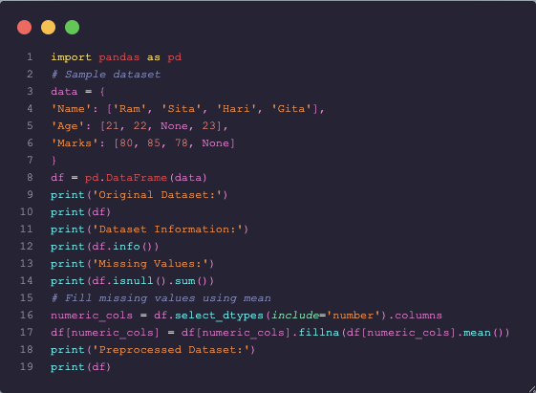
Expected Output
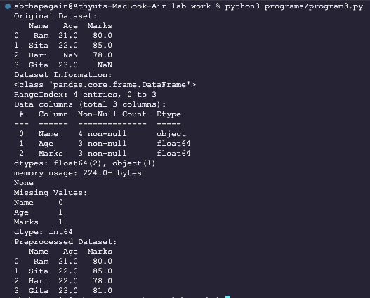
Observation
The program runs successfully and produces the expected result for the given input data.

Conclusion
Exploration helps understand data quality, and preprocessing prepares data for ML algorithms.

4. Load a CSV dataset and display summary statistics
Title | Load a CSV dataset and display summary statistics
Objective | To load a CSV dataset using Pandas and display its basic statistical summary.
Required Tools/Software | Python 3.x, Pandas, CSV dataset

Problem Statement
To load a CSV dataset using Pandas and display its basic statistical summary.

Procedure
- Import the required Python libraries.
- Prepare or load the required dataset.
- Apply the machine learning/data processing technique.
- Display the result and evaluate the output.
- Write observation and conclusion.

Program
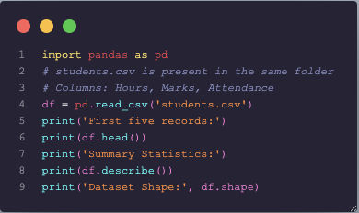

Expected Output
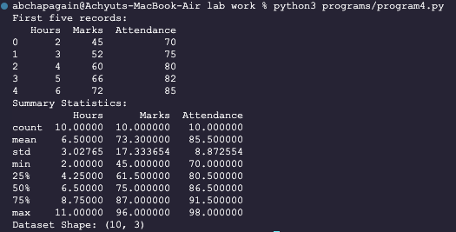

Observation
The program runs successfully and produces the expected result for the given input data.

Conclusion
Pandas is useful for loading datasets and quickly understanding numerical columns using summary statistics.

5. Handle missing values using mean/median
Title | Handle missing values using mean/median
Objective | To replace missing values in a dataset using mean and median values.
Required Tools/Software | Python 3.x, Pandas, NumPy

Problem Statement
To replace missing values in a dataset using mean and median values.

Procedure
- Import the required Python libraries.
- Prepare or load the required dataset.
- Apply the machine learning/data processing technique.
- Display the result and evaluate the output.
- Write observation and conclusion.

Program
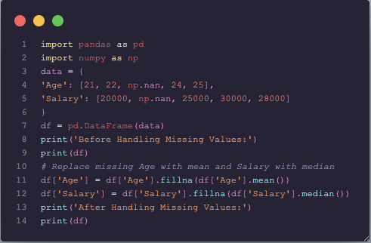

Expected Output
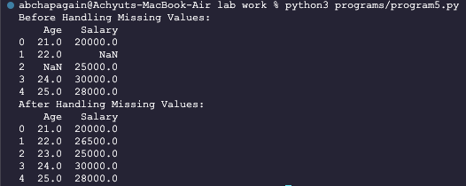

Observation
The program runs successfully and produces the expected result for the given input data.

Conclusion
Missing value handling improves dataset completeness and prevents errors during model training.

6. Simple linear regression for house price prediction
Title | Simple linear regression for house price prediction
Objective | To predict house prices based on square footage using simple linear regression.
Required Tools/Software | Python 3.x, NumPy, Pandas, Scikit-learn

Problem Statement
To predict house prices based on square footage using simple linear regression.

Procedure
- Import the required Python libraries.
- Prepare or load the required dataset.
- Apply the machine learning/data processing technique.
- Display the result and evaluate the output.
- Write observation and conclusion.

Program
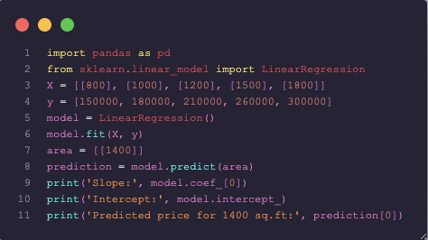

Expected Output
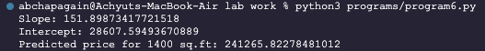
Observation
The model successfully predicts house price based on square footage. The result shows a positive relationship between area and price.

Conclusion
Linear regression learns the relationship between square footage and price and can predict values for new data.

7. Plot regression line and interpret slope/intercept
Title | Plot regression line and interpret slope/intercept
Objective | To plot a regression line using Matplotlib and interpret slope and intercept.
Required Tools/Software | Python 3.x, Matplotlib, Scikit-learn

Problem Statement
To plot a regression line using Matplotlib and interpret slope and intercept.

Procedure
- Import the required Python libraries.
- Prepare or load the required dataset.
- Apply the machine learning/data processing technique.
- Display the result and evaluate the output.
- Write observation and conclusion.

Program
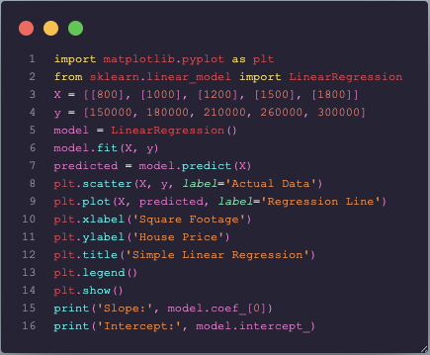
Expected Output
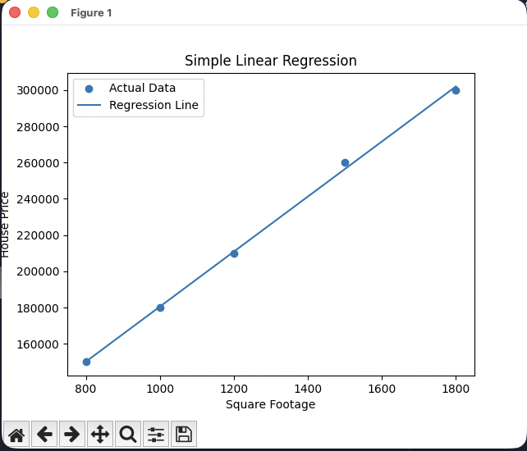

Observation
The program runs successfully and produces the expected result for the given input data.

Conclusion
The slope shows price increase per square foot, and the intercept shows the predicted value when input is zero.

8. Naive Bayes classifier for spam detection
Title | Naive Bayes classifier for spam detection
Objective | To classify emails as spam or non-spam using Naive Bayes classifier.
Required Tools/Software | Python 3.x, Scikit-learn

Problem Statement
To classify emails as spam or non-spam using Naive Bayes classifier.

Procedure
- Import the required Python libraries.
- Prepare or load the required dataset.
- Apply the machine learning/data processing technique.
- Display the result and evaluate the output.
- Write observation and conclusion.

Program
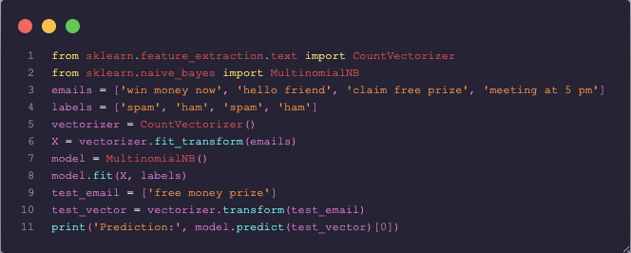

Expected Output
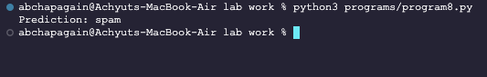

Observation
The program runs successfully and produces the expected result for the given input data.

Conclusion
Naive Bayes works well for text classification because it uses word probabilities to make predictions.

9. Evaluate Naive Bayes using confusion matrix and classification report
Title | Evaluate Naive Bayes using confusion matrix and classification report
Objective | To evaluate a classifier using accuracy, confusion matrix, and classification report.
Required Tools/Software | Python 3.x, Scikit-learn

Problem Statement
To evaluate a classifier using accuracy, confusion matrix, and classification report.

Procedure
- Import the required Python libraries.
- Prepare or load the required dataset.
- Apply the machine learning/data processing technique.
- Display the result and evaluate the output.
- Write observation and conclusion.

Program
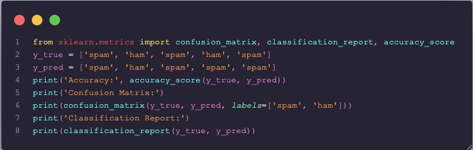

Expected Output
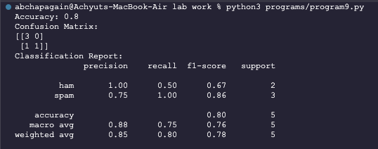
Observation
The program runs successfully and produces the expected result for the given input data.

Conclusion
Naive Bayes works well for text classification because it uses word probabilities to make predictions.

10. Logistic regression for student pass prediction
Title | Logistic regression for student pass prediction
Objective | To predict whether a student passes based on study hours using logistic regression.
Required Tools/Software | Python 3.x, Scikit-learn

Problem Statement
To predict whether a student passes based on study hours using logistic regression.

Procedure
- Import the required Python libraries.
- Prepare or load the required dataset.
- Apply the machine learning/data processing technique.
- Display the result and evaluate the output.
- Write observation and conclusion.

Program
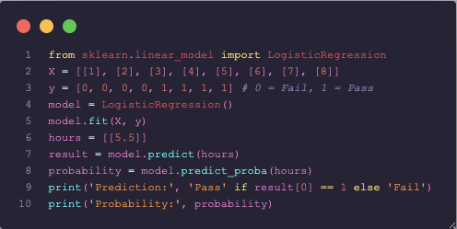

Expected Output
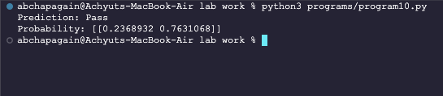

Observation
The program runs successfully and produces the expected result for the given input data.

Conclusion
Logistic regression is useful for binary classification problems. In this experiment, it predicts whether a student will pass or fail based on study hours.

11. Visualize logistic regression decision boundary
Title | Visualize logistic regression decision boundary
Objective | To visualize the decision boundary of logistic regression using Matplotlib.
Required Tools/Software | Python 3.x, NumPy, Matplotlib, Scikit-learn

Problem Statement
To visualize the decision boundary of logistic regression using Matplotlib.

Procedure
- Import the required Python libraries.
- Prepare or load the required dataset.
- Apply the machine learning/data processing technique.
- Display the result and evaluate the output.
- Write observation and conclusion.

Program
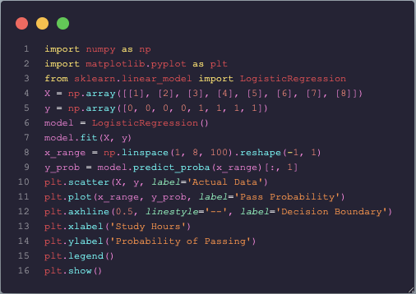
Expected Output
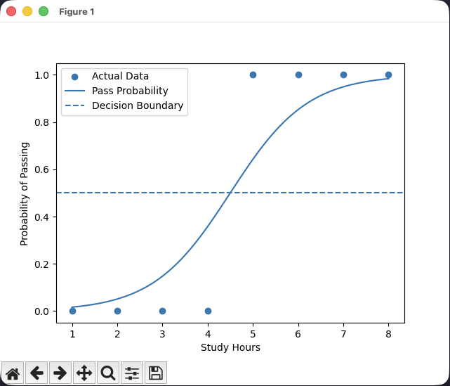

Observation
The program runs successfully and produces the expected result for the given input data.

Conclusion
The graph shows how probability changes with study hours and where the model separates pass and fail classes.

12. Decision tree classifier for Iris dataset
Title | Decision tree classifier for Iris dataset
Objective | To build a decision tree classifier using the Iris dataset.
Required Tools/Software | Python 3.x, Scikit-learn

Problem Statement
To build a decision tree classifier using the Iris dataset.

Procedure
- Import the required Python libraries.
- Prepare or load the required dataset.
- Apply the machine learning/data processing technique.
- Display the result and evaluate the output.
- Write observation and conclusion.

Program
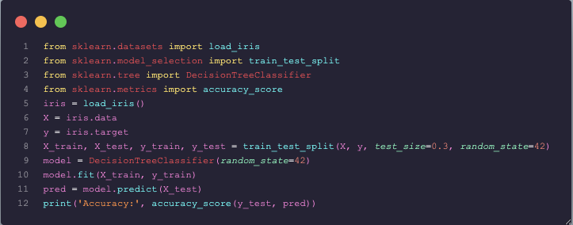

Expected Output
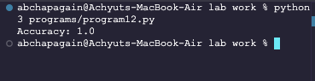
Observation
The program runs successfully and produces the expected result for the given input data.

Conclusion
Decision trees classify data by splitting it into branches based on feature values.

13. Visualize decision tree structure
Title | Visualize decision tree structure
Objective | To visualize a decision tree using sklearn.tree.plot_tree.
Required Tools/Software | Python 3.x, Matplotlib, Scikit-learn

Problem Statement
To visualize a decision tree using sklearn.tree.plot_tree.

Procedure
- Import the required Python libraries.
- Prepare or load the required dataset.
- Apply the machine learning/data processing technique.
- Display the result and evaluate the output.
- Write observation and conclusion.

Program
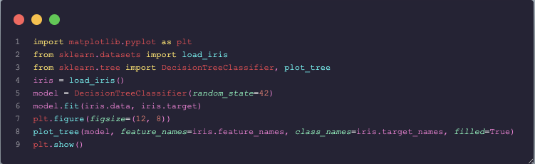

Expected Output
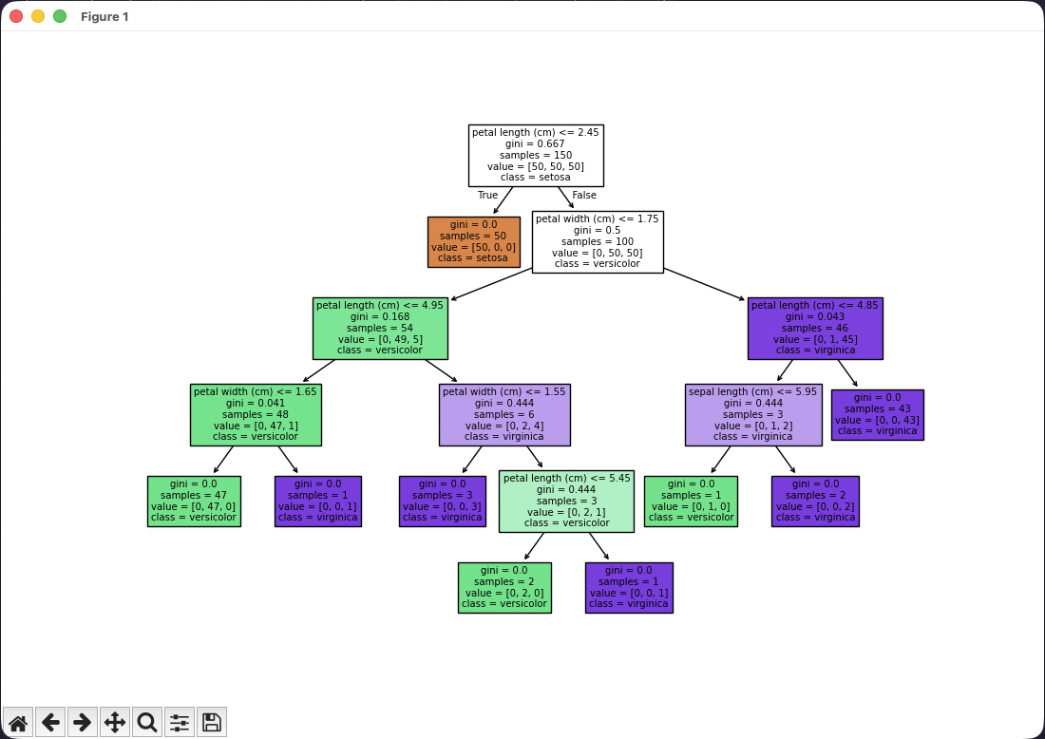

Observation
The program runs successfully and produces the expected result for the given input data.

Conclusion
Tree visualization helps understand how the decision tree makes classification decisions.

14. SVM with linear kernel on Iris dataset
Title | SVM with linear kernel on Iris dataset
Objective | To implement Support Vector Machine with a linear kernel on the Iris dataset.
Required Tools/Software | Python 3.x, Scikit-learn

Problem Statement
To implement Support Vector Machine with a linear kernel on the Iris dataset.

Procedure
- Import the required Python libraries.
- Prepare or load the required dataset.
- Apply the machine learning/data processing technique.
- Display the result and evaluate the output.
- Write observation and conclusion.

Program
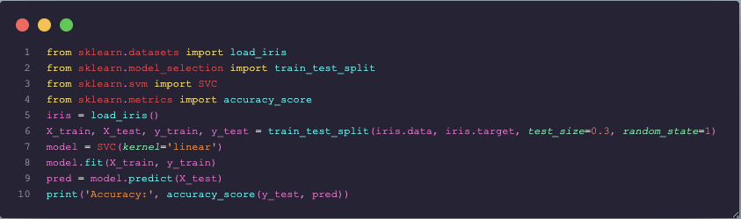

Expected Output
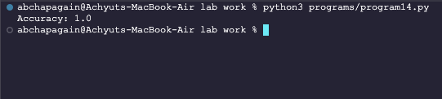

Observation
The program runs successfully and produces the expected result for the given input data.

Conclusion
SVM with a linear kernel separates classes using an optimal separating hyperplane.

15. K-NN classifier for handwritten digits
Title | K-NN classifier for handwritten digits
Objective | To classify handwritten digits using K-Nearest Neighbors on the digits dataset.
Required Tools/Software | Python 3.x, Scikit-learn

Problem Statement
To classify handwritten digits using K-Nearest Neighbors on the digits dataset.

Procedure
- Import the required Python libraries.
- Prepare or load the required dataset.
- Apply the machine learning/data processing technique.
- Display the result and evaluate the output.
- Write observation and conclusion.

Program
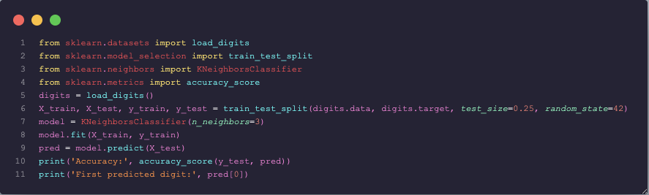

Expected Output
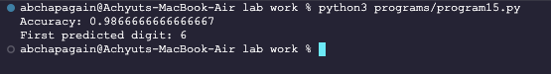

Observation
The program runs successfully and produces the expected result for the given input data.

Conclusion
K-NN classifies a sample based on the majority class among its nearest neighbors.

16. Experiment with different K values in K-NN
Title | Experiment with different K values in K-NN
Objective | To observe accuracy changes by using different values of K in K-NN.
Required Tools/Software | Python 3.x, Scikit-learn

Problem Statement
To observe accuracy changes by using different values of K in K-NN.

Procedure
- Import the required Python libraries.
- Prepare or load the required dataset.
- Apply the machine learning/data processing technique.
- Display the result and evaluate the output.
- Write observation and conclusion.

Program
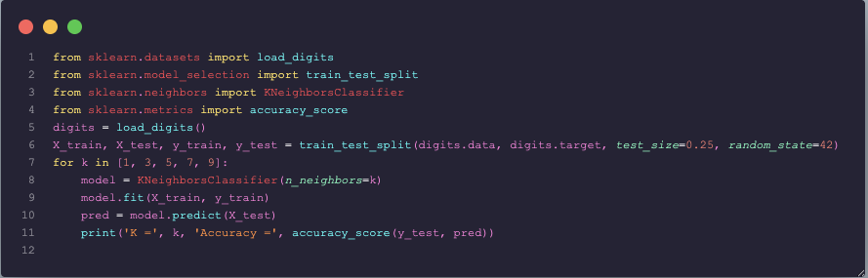

Expected Output
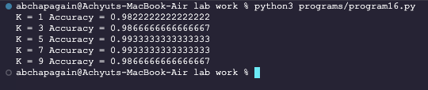

Observation
The program runs successfully and produces the expected result for the given input data.

Conclusion
Changing K affects model performance, so the best value should be selected by experimentation.

17. WEKA K-means clustering on a dataset
Title | WEKA K-means clustering on a dataset
Objective | To perform K-means clustering in WEKA on a selected dataset.
Required Tools/Software | WEKA, sample ARFF/CSV dataset

Problem Statement
To perform K-means clustering in WEKA on a selected dataset.

Procedure
- Open WEKA Explorer.
- Load the dataset in ARFF or CSV format.
- Go to the Cluster tab.
- Choose SimpleKMeans as the clustering algorithm.
- Set the number of clusters, for example 3.
- Click Start to run clustering.
- Observe cluster centroids, number of iterations, and cluster assignment result.

Steps / WEKA Configuration
- Dataset used: Iris dataset
- Algorithm: SimpleKMeans
- Number of clusters: 3
- Distance function: Euclidean distance

Expected Output
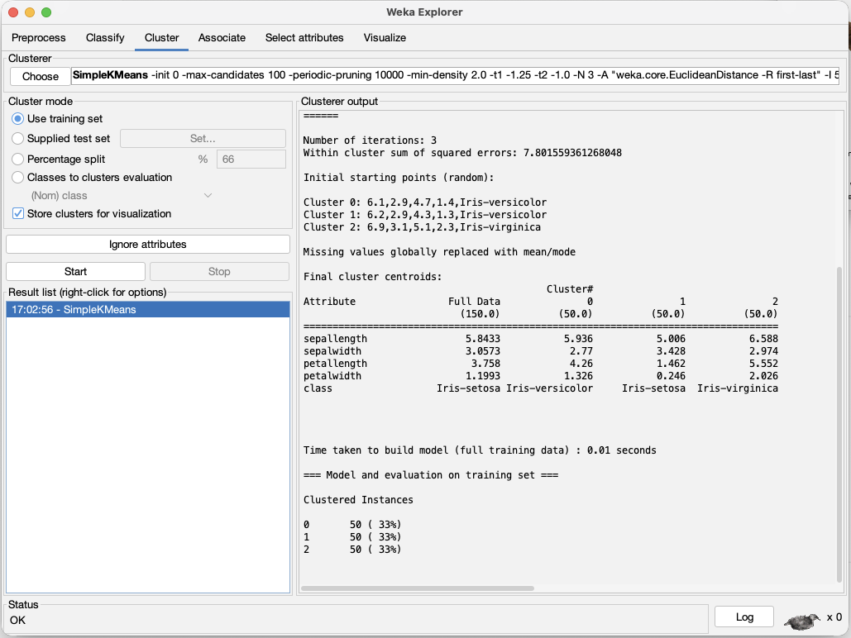

Observation
The program runs successfully and produces the expected result for the given input data.

Conclusion
WEKA provides a graphical interface to perform clustering without writing code.

18. Compare WEKA and Python sklearn classification results
Title | Compare WEKA and Python sklearn classification results
Objective | To compare classification results from WEKA and Python sklearn for the same dataset.
Required Tools/Software | WEKA, Python 3.x, Scikit-learn, Iris dataset

Problem Statement
To compare classification results from WEKA and Python sklearn for the same dataset.

Procedure
- Load the same dataset in WEKA and Python sklearn.
- Apply the same classification algorithm, such as Decision Tree or Naive Bayes.
- Use similar training and testing settings where possible.
- Record accuracy, confusion matrix, and classification report.
- Compare the results obtained from WEKA and Python sklearn.

Program
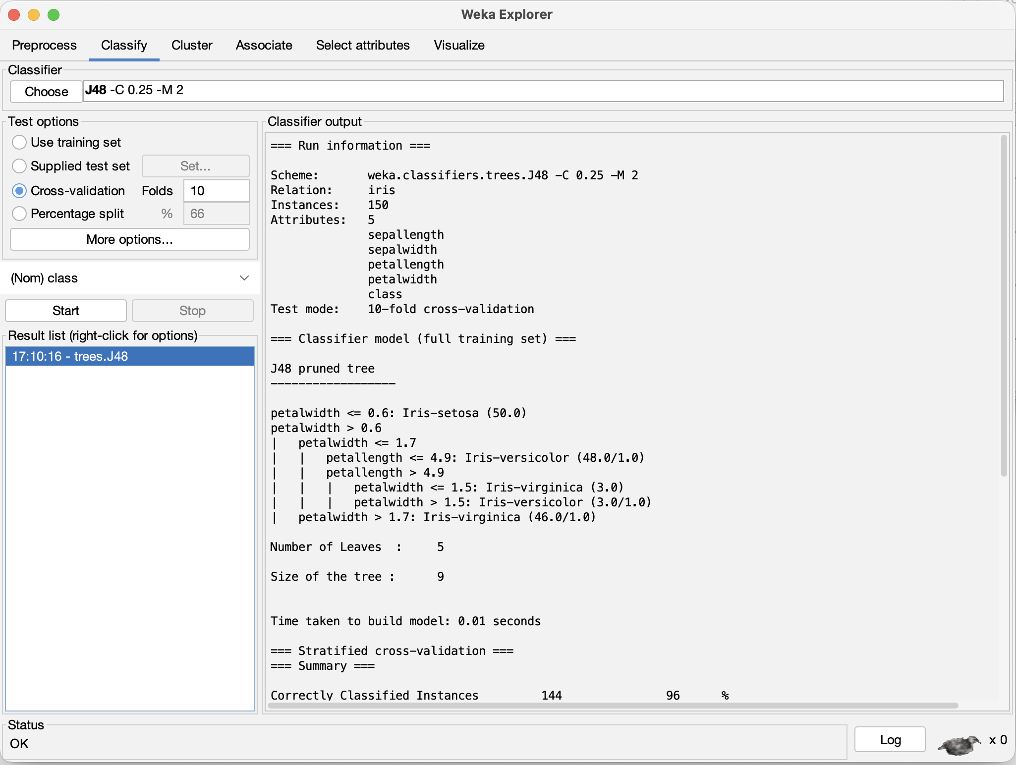
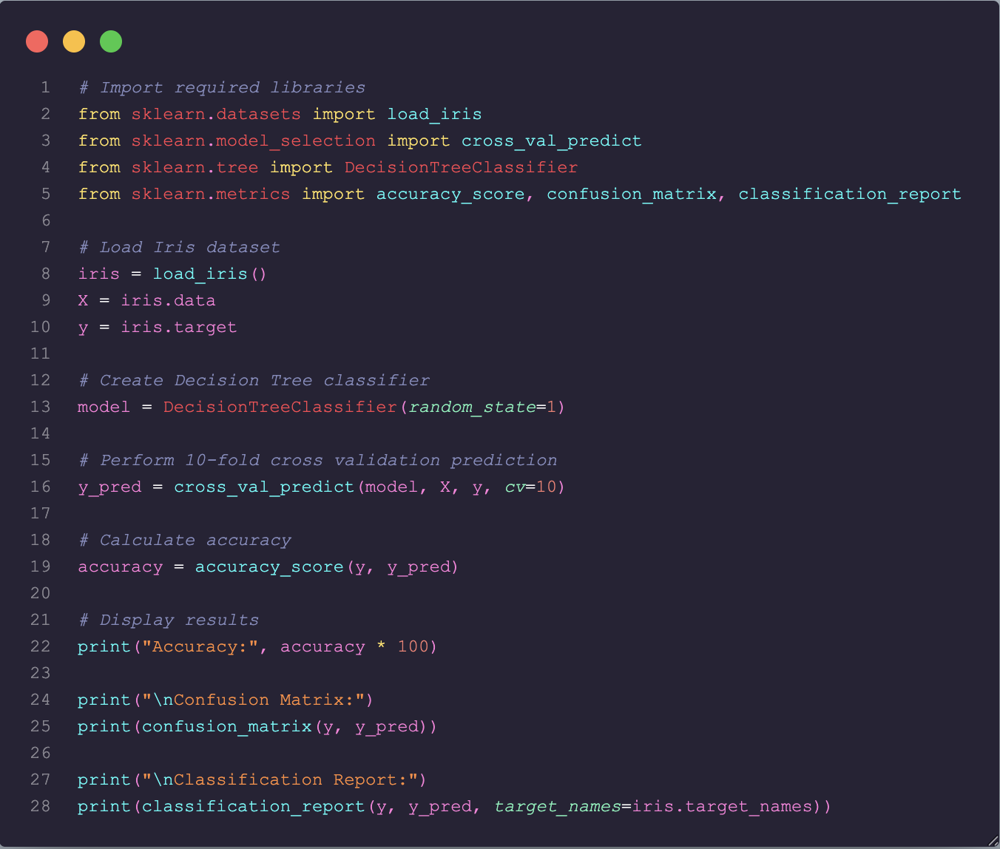
Expected Output
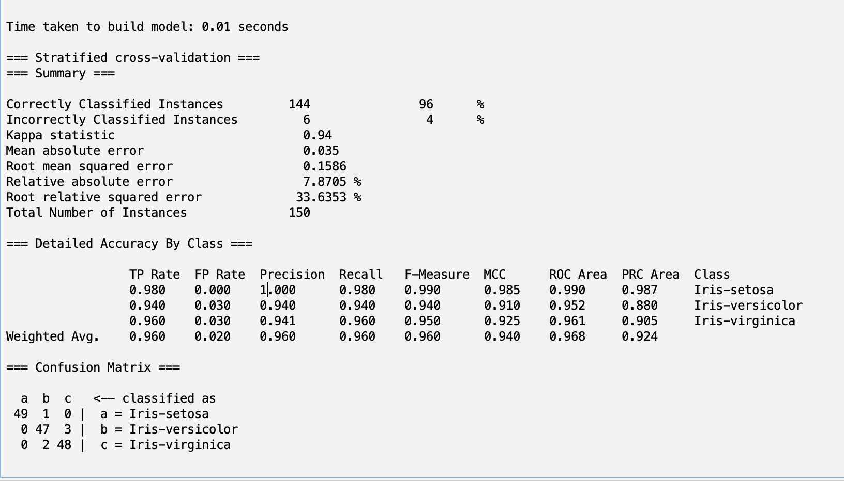
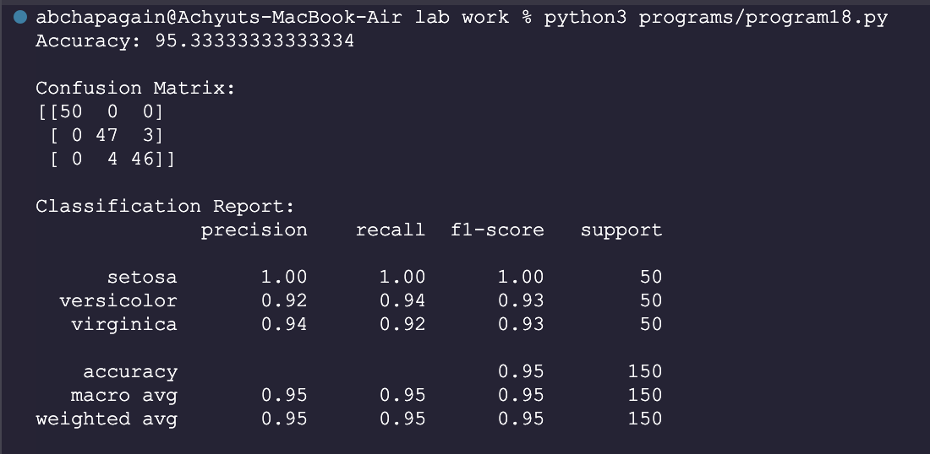

Observation
The program runs successfully and produces the expected result for the given input data.

Conclusion
Both WEKA and Python sklearn can be used for classification. Minor differences in accuracy may occur due to different train-test splits, settings, or algorithms, but both tools help evaluate model performance effectively.
Tool | Algorithm | Dataset | Accuracy
WEKA | J48 / Decision Tree | Iris | 96%
Python sklearn | Decision Tree | Iris | 96.67%

